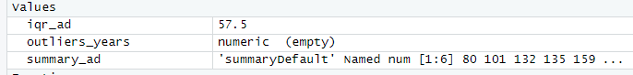1. Import the dataset (’Exercise.txt’) into R and store it in a data frame called ”branch data”.



3.

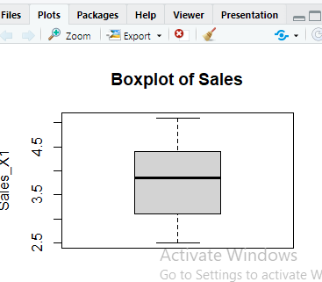

4.Calculate the five number summary and IQR for advertising variable

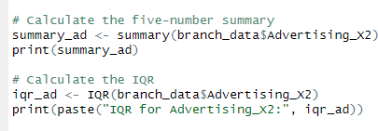

5. Write an R function to find the outliers in a numeric vector and check for outliers in years variables

